[**Module 05 Lesson – Capturing Actionable Insights**](https://learning.rasmussen.edu/webapps/blackboard/content/listContent.jsp?course_id=_67422_1&content_id=_6076798_1&mode=reset)

**Reading** -

* *Data Visualization: A Successful Design Process*
  + Chapter 6. Constructing and Evaluating Your Design Solution
    - Permalink: <http://go.oreilly.com/rasmussen-college/library/view/data-visualization-a/9781849693462/ch06.html>
* *Storytelling with Data: A Data Visualization Guide for Business Professionals*
  + Chapter 8 Pulling it all together
    - Permalink: <http://go.oreilly.com/rasmussen-college/library/view/storytelling-with-data/9781119002253/c08.xhtml>

This lecture will focus on two topics which are commonly used in business, but not often understood. Having knowledge of these concepts will make you much more prepared to handle a diverse set of business issues and datasets.

**Pareto Principle (The 80/20 rule)**

Have you ever heard someone say that they used the 80/20 rule? Or say something like 80% of the problem can be attributed to 20% of the base? Why is the 80/20 rule so popular? Is it a myth carried down for years? Is it truly a rule of thumb that can be applied in business? The 80/20 rule is actually a statistical measure that was made famous by Vilfredo Pareto, an Italian economist from the late 1800s. He first came up with the 80/20 rule after discovering that 20% of the peapods in his garden produced 80% of the peas. This rule of thumb was noted to have consistent results over the years.

Many companies will attest to the fact that a small percentage of customers produce the majority of their revenue. It is a distribution that finds its way into many business applications. But the principle does not always yield a hard and fast 80/20 distribution. It has also known to be 90/10, suggesting that this is not an exact science, but rather an estimate of the distribution. Nonetheless, the Pareto principle has consistently estimated correctly.

Let’s take a personal example, of say a woman who owns 50 pairs of shoes. The 80/20 rule would suggest that the woman regularly wears only 10 pairs (20%) of those shoes. Or a man who has 30 different tools in his garage. He probably only uses about 6 of them regularly for projects. Would you concede that 20% of professional athletes make 80% of the salaries? With these simple examples, you can see how the rule might apply in real life.

**Cumulative Distribution**

The cumulative distribution function is one that is used in statistics very often. People are aware of its use, but not its name. Take a look at Figure 6-1 below. It represents the mathematical view of cumulative distribution. All values range from approximately -3 to 3 in the graph assuming that in both directions the values approach infinity. What this graph essentially states is that approximately 100% of the values fall in this range. In the real world though, variations of this function can exist, including ones which contain no negative values. We will cover these examples in the next paragraph.

*Figure 5-1 Cumulative Distribution Function*

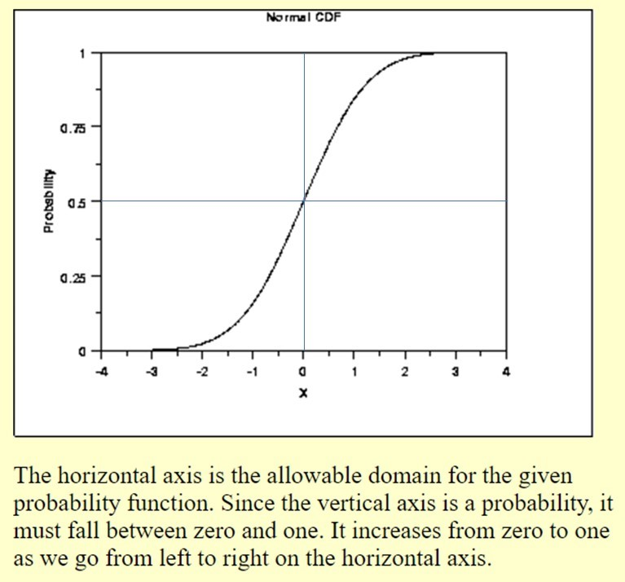

Source (The National Institute of Standards and Technology <https://www.nist.gov/itl>)

Let’s say that you work for a credit card company and you are performing calculations on customers who travel and use their credit card for purchases. A sample set of data for a given month is provided to you in the cumulative distribution graph, Figure 6-2 below. The x-axis represents the amount charged on a credit card for each transaction. The y-axis represents 100% of the charges in the data set, meaning all data is used. Based upon this graph, it can be stated that 70% of the charges are $5 and below. Another statement is that 90% of the credit card charges are below $15. Now by taking the difference between points A and B, it can be concluded that 20% of the credit card purchases range from $5 to $15.

*Figure 5-2 Cumulative Distribution Sample Dataset*

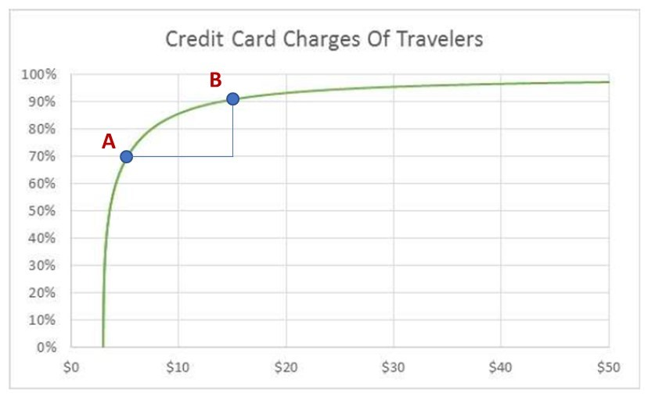

The power of subtracting these values on a cumulative distribution graph (90% - 70%), and relating that to the credit card charge range ($5 to $15) has numerous applications in business and statistics. Once you understand how data within sets are distributed, you can take an extremely large set of data, and simplify it down to some very easy calculations. In the example above, you would be able to draw the conclusion or insight from millions of credit card transactions with a simple mathematical function.

Module 05 Lab Lecture

The purpose of this lab lecture is to provide you with background and guidance to complete the Module 05 Lab.

In this week’s lab, we will be covering logic calculations in Tableau. Completing calculations in Tableau is similar to creating calculations in Excel. There are a number of calculations that can be performed in Tableau, but to cover the entire list of them is beyond the scope of this lecture. It should be noted, however, that Tableau has aggregate calculations, data calculations, logic calculations, table calculations, number calculations, and string calculations just to name a few. For this lab we will be covering logic calculations, but feel free to explore the other Tableau videos in the same section of Tableau’s Learning Community using your student login.

Performing a calculation in Excel is initiated by selecting a cell, then entering the = sign, followed by a formula or some logic, then enter. This saves the formula in the cell and the value displayed will be the result of your calculation. Similarly, in Tableau calculations can be performed on the data set. To accomplish this though, you will need to have an understanding of how calculations work in Tableau. In Tableau, calculation fields will fall under the section called “Measures” on the left side navigation. You can select from pre-populated fields or create your own calculation.

Since Tableau is a data visualization tool, it is easy to see calculation fields visualized. A custom calculated field can be added and dragged onto the main view in Tableau. There is a distinction between regular calculations and table calculations. Regular calculations are handled by the data source in Tableau with the resulting set being delivered to Tableau. Table calculations are secondary calculations that are performed on top of the returned results.

Logic calculations are also a function within Tableau. Logic calculations determine if a certain condition is true or false. This is also known as Boolean logic. In business operations, it is often very useful to know if data passes a certain threshold or meets a certain condition. This is accomplished by using logic calculations. Let’s say for example that ABC Company introduces the z-Phone. The z-Phone was launched four months ago in the top 10 markets. ABC Company launched the z-Phone in two smaller markets at the same time. The company now wants to understand how sales of the z-Phone are performing in these markets.

Using logic calculations, ABC Company can set thresholds for sales targets in the top 10 markets and have a different value in the smaller markets. When sales reach the respective thresholds, they will be considered as performing well. Consider the following screenshot. It shows an example of logic calculations for markets which meet a performance threshold. There are two threshold values listed. One for emerging markets and one for standard markets.

*Figure L5-1 Logic Calculations*

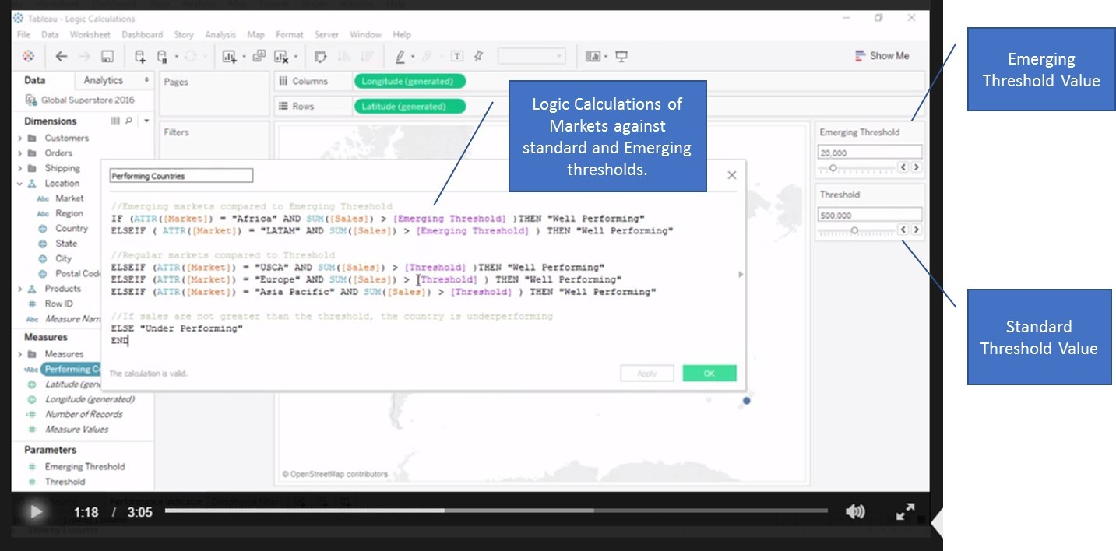

You can now proceed to the lab to learn more about how logic calculations are performed in Tableau.